OUM

IM.090  Migration Instructions

BI ETL Release 2

Author: Venkat Jaligama

Creation Date: Jul 19, 2016

Last update Date: Aug 26 ,2016

Document Ref: BI-ETL-0004, BI-ETL-0005,BI-ETL-0006,BI-ETL-0007,BI-ETL-0008

Version: Draft 1E

1. **Title, Subject, Last Updated Date, Reference Number**, **and** **Version** are marked by a Word Bookmark so that they can be easily reproduced in the header and footer of documents. When you change any of these values, be careful not to accidentally delete the bookmark. **You can make bookmarks visible by selecting the Office Button>Word Options>Advanced> and checking the Show bookmarks option in the Show document content region.**

**Approvals:**

|  |  |
| --- | --- |
| <Approver 1> | Vinay Pachika |
| <Approver 2> | Nagesh Narahari |

1. To add additional approval lines, press [Tab] from the last cell in the table above.
2. You can delete any elements of this cover page that you do not need for your document.

|  |  |
| --- | --- |
| <Approver 3> | Viswam Nair |

# Document Control

## Change Record

40

| Date | Author | Version | Change Reference |
| --- | --- | --- | --- |
| 19-JUL-16 | Venkat | Draft 1A | No Previous Document |
| 07-SEP-16 | Prabhakar | Draft 1B | Updated the TS SVN Version numbers |
| 04-Oct-16 | Jagan | Draft 1C | Included Prod Fixes and P1 performance |
| 13-Oct-16 | Manudeep | Draft 1D | Included modified P1 views |
| 27-Oct-16 | Jagan | Draft 1E | Included new post alloc load plan steps . |
| 08-Nov-16 | Abhishek | Draft 1F | Change Version no for Prod Migration. |

## Reviewers

| Name | Position |
| --- | --- |
|  |  |
|  |  |
|  |  |
|  |  |

Contents

1 Document Control 2

1.1 Change Record 2

1.2 Reviewers 2

2 Installation Instructions for Code Migration 6

2.1 Pre-Migration Steps 6

3 Migration Steps for Incremental Summary Flag(BI-ETL-0004) Change 7

3.1.1 Transfer Database scripts to Target SVN repository 7

3.1.2 Transfer ODI packages to Target SVN Repository 7

3.1.3 Import ODI code components into Target instance 7

3.1.4 Re-generate the Custom ODI Packages 10

Note: When re-generating the senario’s , please ignore scenario variables(ie., no need to select all/specific parameters, leave as is.) Just click on OK to complete the scenario re-generation process. 11

3.1.5 Verification Checklist 12

4 Migration Steps for Incremental PO and Supplier Details(BI-ETL-0004) Change 14

4.1.1 Transfer Database scripts to Target SVN repository 14

4.1.2 Transfer ODI packages to Target SVN Repository 14

Import ODI code components into Target instance 14

4.1.3 Re-generate the Custom ODI Packages 14

Note: When re-generating the senario’s , please ignore scenario variables(ie., no need to select all/specific parameters, leave as is.) Just click on OK to complete the scenario re-generation process. 15

4.1.4 Verification Checklist 15

5 Migration Steps for UnPaid Invoices (BI-ETL-0007) Change 16

5.1.1 Transfer Database scripts to Target SVN repository 16

5.1.2 Transfer ODI packages to Target SVN Repository 16

Import ODI code components into Target instance 16

5.1.3 Re-generate the Custom ODI Packages 16

Note: When re-generating the senario’s , please ignore scenario variables(ie., no need to select all/specific parameters, leave as is.) Just click on OK to complete the scenario re-generation process. 17

5.1.4 Verification Checklist 17

6 Migration Steps for PostAllocation Expenses (BI-ETL-0006) Change 18

6.1.1 Transfer Database scripts to Target SVN repository 18

6.1.2 Transfer Database scripts to Target SVN repository - EBS 18

6.1.3 Transfer ODI packages to Target SVN Repository 19

Import ODI code components into Target instance 19

6.1.4 Re-generate the Custom ODI Packages 19

Note: When re-generating the senario’s , please ignore scenario variables(ie., no need to select all/specific parameters, leave as is.) Just click on OK to complete the scenario re-generation process. 20

6.1.5 Verification Checklist 20

7 Migration Steps for CES Redistribution Ratio (BI-ETL-0005) Change 22

7.1.1 Transfer Database scripts to Target SVN repository 22

7.1.2 Transfer ODI packages to Target SVN Repository 22

Import ODI code components into Target instance 23

7.1.3 Re-generate the Custom ODI Packages 23

Note: When re-generating the senario’s , please ignore scenario variables(ie., no need to select all/specific parameters, leave as is.) Just click on OK to complete the scenario re-generation process. 23

7.1.4 Verification Checklist 23

8 Migration Steps for Control Table (BI-ETL-0008) Change 25

8.1.1 Transfer Database scripts to Target SVN repository 25

8.1.2 Transfer ODI packages to Target SVN Repository 25

Import ODI code components into Target instance 25

8.1.3 Re-generate the Custom ODI Packages 26

Note: When re-generating the senario’s , please ignore scenario variables(ie., no need to select all/specific parameters, leave as is.) Just click on OK to complete the scenario re-generation process. 26

8.1.4 Verification Checklist 26

9 ODI Load Plan components deployment 27

9.1.1 Transfer ODI Load plan components to Target SVN Repository 27

Import ODI code components into Target instance 27

9.1.2 Verify the above Imported LP steps 30

10 Migration Steps for Units Change 33

10.1.1 Transfer Database scripts to Target SVN repository 33

10.1.2 Transfer ODI packages to Target SVN Repository 33

Import ODI code components into Target instance 33

10.1.3 Re-generate the Custom ODI Packages 34

Note: When re-generating the senario’s , please select all/specific parameters and click on OK to complete the scenario re-generation process. 34

10.1.4 Verification Checklist 34

11 Migration Steps for P1 Performance fix 35

11.1.1 Transfer Database scripts to Target SVN repository - EBS 35

11.1.2 Transfer Database scripts to Target SVN repository - DW 35

11.1.3 Transfer ODI packages to Target SVN Repository 35

12 Migration Steps for Creating New Load Plan for the Post-Alloc 37

13 Re-Generate Load Plan in the Target instance 43

13.1 Execute Load Plan in the Target instance 43

14 Execute the Historical Scripts after the Incremental load(DBA) 45

15 Open and Closed Issues 46

15.1 Open Issues 46

15.2 Closed Issues 46

1. To update the table of contents, put the cursor anywhere in the table and press [F9]. To change the number of levels displayed, select the menu option Insert‑>Index and Tables, make sure the Table of Contents tab is active, and change the Number of Levels to a new value.

# Installation Instructions for Code Migration

|  |  |
| --- | --- |
| **Source Environment Name:** UAT | **Machine: TCGI13** |

|  |  |
| --- | --- |
| **Target Environment Name:** PROD | **Machine: PCGIT3** |

## Pre-Migration Steps

* Login to the ODI studio and apply the <Target> Environment Repository Connection Information and ensure you are able to connect to the Repository with the given user credentials
* Export the ODI Topology of the Target Instance for the backup for the very first time migration

Goto> ODI Studio client> Topology Navigator > click on Connect Navigator > Export > Select Export the Topology> Save it on your local (backup)

* Able to access the ODI Enterprise Configuration manager application with the user credentials
* Ensure the credentials are ready with the Source database and Target Datawarehouse environment details being migrated
* Take the ODIREPO schema database backup of the target instance if the load is executed for the very first time in the target instance.
* Drop all the temp tables in the Target instance by running the below query

SELECT Table_Name, Num_Rows

FROM All_Tables

WHERE (Table_Name LIKE 'C$%'

        OR Table_Name LIKE 'I$%')

      AND Num_Rows > 0

ORDER BY Num_Rows DESC;

* Once the import is successful without any errors/warnings, save the changes.
* When ever we generate a new Load plan , make sure to add the exception email ODI alert scenario.
* **NOTE**: Please capture all the deployment successful screen shots for DEV team reference

# Migration Steps for Incremental Summary Flag(BI-ETL-0004) Change

### Transfer Database scripts to Target SVN repository

**NOTE:** Ensure the SVN update is complete before downloading the files from the SVN

* Copy below table creation scripts from Source SVN repository to target repository

SVN Base Path: http://subversion.sys.cigna.com/svn/ORACLE_BI_REPO

Source Location: <Source>MAIN\DBScripts/Tables/Release 2

Target Location : <Target>_MAIN\DBScripts/Tables/Release 2

Execute scripts in the database-DW Schema(DBA)

|  |  |  |  |  |  |  |
| --- | --- | --- | --- | --- | --- | --- |
| **Script #** | **Dev Version #** | **TS Version#** | **CRP1 Version#** | **UAT Version#** | **PROD Version#** | **File Name** |
| 1 | 1238 | 1279 | 1360 | 1392 |  | X_SUMMARY_FLAG_REL2_ALTR.sql |

* Do Commit

### Transfer ODI packages to Target SVN Repository

* Copy below ODI objects from Source SVN repository to target repository

SVN Base Path: <http://subversion.sys.cigna.com/svn/ORACLE_BI_REPO>

Source Location: <Source>_ MAIN/ODI/OOTB_Custom/Release 2

Target Location : <Target>_MAIN\ODI\OOB_Custom\ Release 2

|  |  |  |  |  |  |  |
| --- | --- | --- | --- | --- | --- | --- |
| **Script #** | **Dev Version #** | **TS Version#** | **CRP1 Version#** | **UAT Version#** | **PROD Version#** | **File Name** |
| 1. | 1252 | 1278 | 1364 | 1392 |  | SDE_ORA_CostCenterDimension.zip |
| 2. | 1252 | 1278 | 1364 | 1392 |  | SIL_CostCenterDimension.zip |
| 3. | 1252 | 1278 | 1364 | 1392 |  | SDE_ORA_NaturalAccountDimension.zip |
| 4. | 1252 | 1278 | 1364 | 1392 |  | SIL_NaturalAccountDimension.zip |
| 5. | 1252 | 1278 | 1364 | 1392 |  | SDE_ORA_BalancingSegmentDimension.zip |
| 6. | 1252 | 1278 | 1364 | 1392 |  | SIL_BalancingSegmentDimension.zip |

* Do SVN Commit

### Import ODI code components into Target instance

* Log into ODI Studio with a user as bi apps administrator.
* Import ODI objects into the target instance as shown in the screen shot below.
* Desginer Navigation: Go to Projects 🡪 click on Connect Navigator --> Select Import

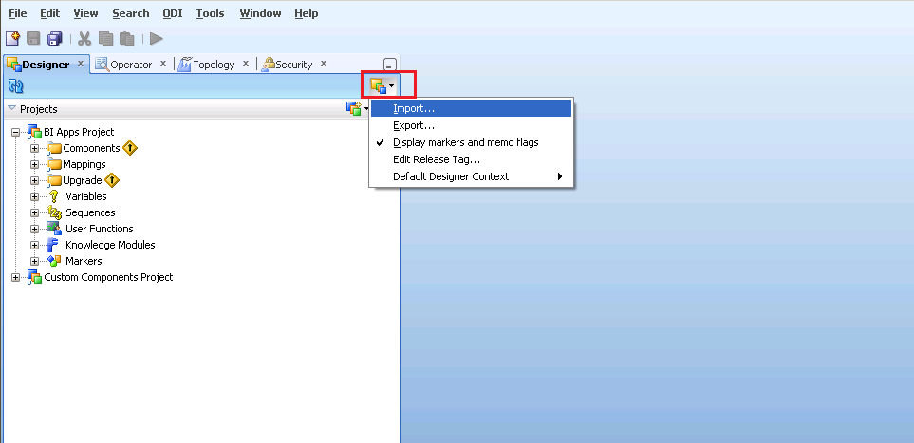

* Select the option Smart Import and then clieck Ok

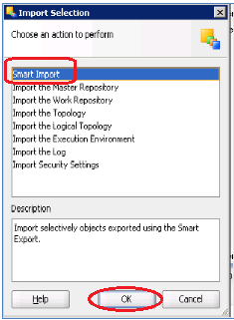

* Browse and Select the ZIP files downloaded from SVN listed below: (Only one file can be selected at a time)



* **Note**: At the Import Actions step, Goto Topology Section--> Select each component beneath it and mark the Action = Ignore from the dropdown values (this applies for only Topology,else ignore this Topology section)

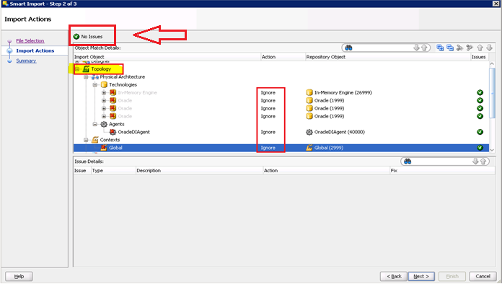

* Check if any errrors on the top, if No Issues displayed then Click Next
* Complete importing every file listed below by following the above steps sequence. Save the log and send to dev team if errors are encountered.

NOTE: You can ignore/overwrite the OOB table(W_%) errors shown while importing any of the above packages

### Re-generate the Custom ODI Packages

* Regenerate the below Custom package scenarios

Desginer : Goto Projects > BI Apps Project > Mappings > CUSTOM_SDE_ORAR1213_Adaptor>File Name>Packages>Scenarios >Right click Re-generate

& CUSTOM_SILOS_ORAR1213_Adaptor>File Name>Packages>Scenarios >Right click Re-generate

| Script # | File Name |
| --- | --- |
|  | SDE_ORAR1213_ADAPTOR_SDE_ORA_COSTCENTERDIMENSION |
|  | SILOS_SIL_COSTCENTERDIMENSION |
|  | SDE_ORAR1213_ADAPTOR_SDE_ORA_BALANCINGSEGMENTDIMENSION |
|  | SILOS_SIL_NATURALACCOUNTDIMENSION |
|  | SDE_ORAR1213_ADAPTOR_SDE_ORA_NATURALACCOUNTDIMENSION |
|  | SILOS_SIL_BALANCINGSEGMENTDIMENSION |

Example:

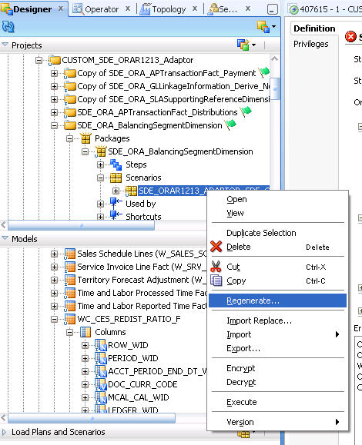

### Note: When re-generating the senario’s , please ignore scenario variables(ie., no need to select all/specific parameters, leave as is.) Just click on OK to complete the scenario re-generation process.

### Verification Checklist

1. Include a subset of test steps that will confirm that the customization has been installed properly.

Verify that the deployment has been completed successfully by following these steps:

After importing the above code into ODI, add the X_SUMMARY_FLAG column to SCD as shown below.

ODI Designer->Model-> Oracle BI Applications>Dimension-> W_COST_CENTER_D, Double click on X_SUMMARY_FLAG and check below changes exists.

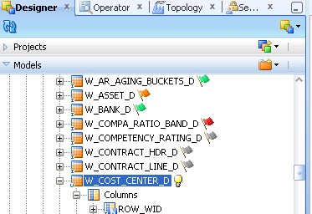

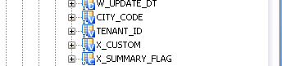

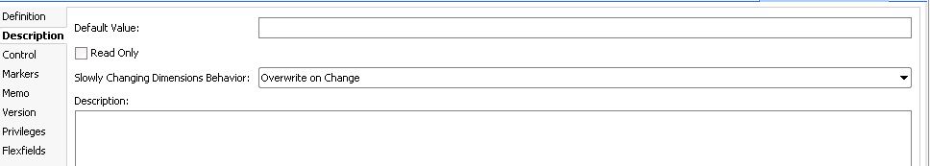

Similarly check for w_natural_accound_d and w_balancing_segment_d table’s x_summary_flag column.

**New Components – Sanity Check in ODI Model**

In the ODI Model, verify the below tables and views:

Model> Oracle BI Applications>Dimesions

|  |  |  |  |  |
| --- | --- | --- | --- | --- |
| **Slno** | **Component_Type** | **Component_name** | **Change Desc** | **Location** |
| 1 | Table | W_COST_CENTER_D | X_SUMMARY_FLAG column should be added. | Model> Oracle BI Applications>Dimesions |
| 2 | Table | W_NATURAL_ACCOUNT_D | X_SUMMARY_FLAG column should be added. | Model> Oracle BI Applications>Dimesions |
| 3 | Table | W_BALANCING_SEGMENT_D | X_SUMMARY_FLAG column should be added. | Model> Oracle BI Applications>Dimesions |

All the components in the ETL_BI 0004 should be displayed, please do the following high level components in the ODI Studio, under the CUSTOM_SDE_ORAR1213_Adaptor & Custom_SILOS_ORAR1213_Adaptor.

|  |  |
| --- | --- |
| 1 | SDE_ORA_CostCenterDimension |
| 2 | SIL_CostCenterDimension |
| 3 | SDE_ORA_NaturalAccountDimension |
| 4 | SIL_NaturalAccountDimension |
| 5 | SDE_ORA_BalancingSegmentDimension |
| 6 | SIL_BalancingSegmentDimension |

# Migration Steps for Incremental PO and Supplier Details(BI-ETL-0004) Change

### Transfer Database scripts to Target SVN repository

**NOTE:** Ensure the SVN update is complete before downloading the files from the SVN

* Copy below table creation scripts from Source SVN repository to target repository

SVN Base Path: http://subversion.sys.cigna.com/svn/ORACLE_BI_REPO

Source Location: <Source>_ MAIN\DBScripts\Tables\Release 2

Target Location : <Target>_MAIN\ DBScripts \Tables\ Release 2

#### Execute scripts in the database-DW Schema(DBA)

|  |  |  |  |  |  |  |
| --- | --- | --- | --- | --- | --- | --- |
| Script # | Dev Version # | TS Version# | CRP1 Version# | UAT Version# | PROD Version# | File Name |
|  | 1238 | 1278 | 1361 | 1392 |  | X_PO_VENDOR_DTL_REL_2_ALTR.sql |

* Do Commit

### Transfer ODI packages to Target SVN Repository

* Copy below list ODI objects from Source SVN repository to target repository

SVN Base Path: <http://subversion.sys.cigna.com/svn/ORACLE_BI_REPO>

Source Location: <Source>_MAIN\ODI\OOB_Custom \ Release 2

Target Location : <Target>_MAIN\ODI\OOB_Custom\ Release 2

### Import ODI code components into Target instance

Please refer to the Section 3.1.3 on how to import the scenarios.

* Complete smart importing every file listed below by following the above **Section 3.1.3** steps sequence. Save the log and send to dev team if errors are encountered.

|  |  |  |  |  |  |  |
| --- | --- | --- | --- | --- | --- | --- |
| **Script #** | **Dev Version #** | **TS Version#** | **CRP1 Version#** | **UAT Version#** | **PROD Version#** | **File Name** |
| 1. | 1252 | 1278 | 1364 | 1392 |  | SDE_ORA_FixedAssetDimension.zip |
| 2. | 1252 | 1278 | 1364 | 1392 |  | SIL_FixedAssetDimension.zip |

* Do SVN Commit

**NOTE:** You can ignore/overwrite the OOB table(W_%) errors shown while importing any of the above packages

### Re-generate the Custom ODI Packages

* Regenerate the below Custom package scenarios

Desginer : Goto Projects > BI Apps Project > Mappings > Folder Name>Packages>Scenarios >Right click Re-generate

& >Folder Name>Packages>Scenarios >Right click Re-generate

| Script # | File Name | Folder Name |
| --- | --- | --- |
|  | SDE_ORAR1213_ADAPTOR_SDE_ORA_FIXEDASSETDIMENSION | ODI Designer->Projects->Mappings->CUSTOM_SDE_ORAR1213_Adaptor-> SDE_ORA_FixedAssetDimension |
|  | SILOS_SIL_FIXEDASSETDIMENSION | ODI Designer->Projects->Mappings-> CUSTOM_SILOS_ORAR1213_Adaptor-> SIL_FixedAssetDimension |

### Note: When re-generating the senario’s , please ignore scenario variables(ie., no need to select all/specific parameters, leave as is.) Just click on OK to complete the scenario re-generation process.

### Verification Checklist

1. Include a subset of test steps that will confirm that the customization has been installed properly.

Verify that the deployment has been completed successfully by following these steps:

**New Components – Sanity Check**

All the components in the ETL_BI 0004 should be displayed, please do the following high level components in the ODI Studio.

In the ODI Model, verify the below tables:

|  |  |  |  |  |
| --- | --- | --- | --- | --- |
| **Slno** | **Component_Type** | **Component_name** | **Change Desc** | **Location** |
| 1 | Table | W_FIXED_ASSET_DS | X_PO_NUMBER and X_PO_VENDOR_ID columns should be present. | Model>OracleBI Applications>DimensionStage |
| 2 | Table | W_FIXED_ASSET_D | X_PO_NUMBER and X_SUPPLIER_WID columns should be present. | Model>OracleBI Applications>Dimension |

# Migration Steps for UnPaid Invoices (BI-ETL-0007) Change

### Transfer Database scripts to Target SVN repository

**NOTE:** Ensure the SVN update is complete before downloading the files from the SVN

* Copy below table creation scripts from Source SVN repository to target repository

SVN Base Path: http://subversion.sys.cigna.com/svn/ORACLE_BI_REPO

Source Location: <Source>_MAIN\DBScripts\Tables\ Release 2

Target Location : <Target>_MAIN\ DBScripts \Tables\ Release 2

#### Execute scripts in the database-DW Schema(DBA)

|  |  |  |  |  |  |  |
| --- | --- | --- | --- | --- | --- | --- |
| Script # | Dev Version # | TS Version# | CRP1 Version# | UAT Version# | PROD Version# | File Name |
| 1. | 1253 | 1279 | 1362 | 1392 |  | WC_AP_UNPAID_INV_FS.sql |
| 2. | 1253 | 1279 | 1362 | 1392 |  | WC_AP_UNPAID_INV_F.sql |

* Do Commit

### Transfer ODI packages to Target SVN Repository

* Copy below list ODI objects from Source SVN repository to target repository

SVN Base Path: <http://subversion.sys.cigna.com/svn/ORACLE_BI_REPO>

Source Location: <Source>_MAIN\ODI\Custom\ Release 2

Target Location : <Target>_MAIN\ODI\Custom\ Release 2

### Import ODI code components into Target instance

Please refer to the Section 3.1.3 on how to import the scenarios.

* Complete smart importing every file listed below by following the above **Section 3.1.3** steps sequence. Save the log and send to dev team if errors are encountered.

|  |  |  |  |  |  |  |
| --- | --- | --- | --- | --- | --- | --- |
| **Script #** | **Dev Version #** | **TS Version#** | **CRP1 Version#** | **UAT Version#** | **PROD Version#** | **File Name** |
| 1. | 1261 | 1279 | 1365 | 1392 |  | SDE_WC_Stage_UnPaid_InvoiceFact.zip |
| 2. | 1386 | 1387 | 1365 | 1392 |  | SIL_WC_AP_UnPaid_Invoices_F.zip |

* Do SVN Commit

**NOTE:** You can ignore/overwrite the OOB table(W_%) errors shown while importing any of the above packages

### Re-generate the Custom ODI Packages

* Regenerate the below Custom package scenarios

Desginer : Goto Projects > BI Apps Project > Mappings > Folder Name>Packages>Scenarios >Right click Re-generate

& >Folder Name>Packages>Scenarios >Right click Re-generate

| Script # | File Name | Folder Name |
| --- | --- | --- |
|  | SDE_WC_Stage_UnPaid_InvoiceFact | ODI Designer->Projects->Mappings->CUSTOM_SDE_Adaptor-> SDE_WC_Stage_UnPaid_InvoiceFact |
|  | SIL_WC_AP_UnPaid_Invoices_F | ODI Designer->Projects->Mappings->CUSTOM_SILOS-> SIL_WC_AP_UnPaid_Invoices_F |

### Note: When re-generating the senario’s , please ignore scenario variables(ie., no need to select all/specific parameters, leave as is.) Just click on OK to complete the scenario re-generation process.

### Verification Checklist

1. Include a subset of test steps that will confirm that the customization has been installed properly.

Verify that the deployment has been completed successfully by following these steps:

**New Components – Sanity Check**

All the components in the ETL_BI 0007 should be displayed, please do the following high level components in the ODI Studio, under the CUSTOM_SDE & Custom_SILOS.

|  |  |
| --- | --- |
| Folder Name | Path |
| SDE_WC_Stage_UnPaid_InvoiceFact | ODI Designer->Projects->Mappings->CUSTOM_SDE_Adaptor-> |
| SIL_WC_AP_UnPaid_Invoices_F | ODI Designer->Projects->Mappings->CUSTOM_SILOS-> SIL_WC_AP_UnPaid_Invoices_F |

In the ODI Model, verify the below tables:

|  |  |  |  |  |
| --- | --- | --- | --- | --- |
| **Slno** | **Component_Type** | **Component_name** | **Change Desc** | **Location** |
| 1 | Table | WC_AP_UNPAID_INV_FS | Staging table for AP Unpaid Invoice details | Model>OracleBI Applications>Fact Stage |
| 2 | Table | WC_AP_UNPAID_INV_F | Fact table for AP Unpaid Invoice details | Model>OracleBI Applications>Fact |

# Migration Steps for PostAllocation Expenses (BI-ETL-0006) Change

### Transfer Database scripts to Target SVN repository

**NOTE:** Ensure the SVN update is complete before downloading the files from the SVN

* Copy below table creation scripts from Source SVN repository to target repository

SVN Base Path: http://subversion.sys.cigna.com/svn/ORACLE_BI_REPO

Source Location: <Source>_MAIN\DBScripts\Tables\ Release 2

Target Location : <Target>_MAIN\ DBScripts \Tables\ Release 2

#### Execute scripts in the database-DW Schema(DBA)

|  |  |  |  |  |  |  |
| --- | --- | --- | --- | --- | --- | --- |
| Script # | Dev Version # | TS Version# | CRP1 Version# | UAT Version# | PROD Version# | File Name |
| 1. | 1261 | 1279 | 1373 | 1392 |  | WC_POSTALLOC_EXP_FS.sql |
| 2. | 1261 | 1279 | 1362 | 1392 |  | WC_POSTALLOC_EXP_F.sql |
| 3. | 1261 | 1279 | 1373 | 1392 |  | WC_POSTALLOC_SOURCES_DS.sql |
| 4. | 1261 | 1279 | 1373 | 1392 |  | WC_POSTALLOC_SOURCES_D.sql |

Source Location : <Source>_MAIN\ DBScripts\Sequences\ Release 2

Target Location : <Target>_MAIN\ DBScripts\Sequences\ Release 2

#### Execute scripts in the database-DW Schema(DBA)

|  |  |  |  |  |  |  |
| --- | --- | --- | --- | --- | --- | --- |
| Script # | Dev Version # | TS Version# | CRP1 Version# | UAT Version# | PROD Version# | File Name |
| 1. | 1261 | 1279 | 1372 | 1392 |  | WC_POSTALLOC_SOURCES_D_SEQ.sql |

Source Location: <Source>_MAIN\DBScripts\Indexes\ Release 2

Target Location: <Source>_MAIN\DBScripts\Indexes\ Release 2

#### Execute scripts in the database-DW Schema(DBA)

|  |  |  |  |  |  |  |
| --- | --- | --- | --- | --- | --- | --- |
| Script # | Dev Version # | TS Version# | CRP1 Version# | UAT Version# | PROD Version# | File Name |
| 1. | 1261 | 1279 | 1374 | 1392 |  | WC_POSTALLOC_EXP_F_INDX.sql |

* + - * + Do commit

### Transfer Database scripts to Target SVN repository - EBS

**NOTE:** Ensure the SVN update is complete before downloading the files from the SVN

* Copy below table creation scripts from Source SVN repository to target repository

SVN Base Path: http://subversion.sys.cigna.com/svn/BFF

Source Location: <Source>\BFF_SVN\Branches\BI\admin\sql\views

Target Location: <Target>\BFF_SVN\Branches\BI\admin\sql\views

#### Execute scripts in the database(EBS) (DBA)

|  |  |  |
| --- | --- | --- |
| Script # | SVN# | File Name |
| 1. | 3651 | XXC_BI_POSTALLOC_EXP_V.sql |
| 2. | 3651 | XXC_BI_POSTALLOC_SOURCES_V.sql |

### Transfer ODI packages to Target SVN Repository

* Copy below list ODI objects from Source SVN repository to target repository

SVN Base Path: <http://subversion.sys.cigna.com/svn/ORACLE_BI_REPO>

Source Location: <Source>_MAIN\ODI\Custom\ Release 2

Target Location : <Target>_MAIN\ODI\Custom\ Release 2

### Import ODI code components into Target instance

Please refer to the Section 3.1.3 on how to import the scenarios.

* Complete smart importing every file listed below by following the above **Section 3.1.3** steps sequence. Save the log and send to dev team if errors are encountered.

|  |  |  |  |  |  |  |
| --- | --- | --- | --- | --- | --- | --- |
| **Script #** | **Dev Version #** | **TS Version#** | **CRP1 Version#** | **UAT Version#** | **PROD Version#** | **File Name** |
| 1. | 1261 | 1279 | 1366 | 1392 |  | SDE_WC_Stage_PostAllocExpensesFact.zip |
| 2. | 1285 | 1286 | 1366 | 1392 |  | SIL_WC_POSTALLOC_EXP_F.zip |
| 3. | 1285 | 1288 | 1366 | 1392 |  | SDE_WC_Stage_PostallocSourceDimension.zip |
| 4. | 1285 | 1286 | 1366 | 1392 |  | SIL_WC_PostallocSourceDimension.zip |
| 5. | 1296 | 1297 | 1366 | 1392 |  | SDE_WC_Stage_Refresh_Variables.zip |

**NOTE:** You can ignore/overwrite the OOB table(W_%) errors shown while importing any of the above packages

### Re-generate the Custom ODI Packages

* Regenerate the below Custom package scenarios

Desginer : Goto Projects > BI Apps Project > Mappings > Folder Name>Packages>Scenarios >Right click Re-generate

| Script # | File Name | Folder Name |
| --- | --- | --- |
| 1. | SDE_WC_Stage_PostAllocExpensesFact | ODI Designer->Projects->Mappings->CUSTOM_SDE_Adaptor-> SDE_WC_Stage_PostAllocExpenses |
| 2. | SIL_WC_POSTALLOC_EXP_F | ODI Designer->Projects->Mappings->CUSTOM_SILOS-> SIL_WC_POSTALLOC_EXP_F |
| 3. | SDE_WC_STAGE_POSTALLOCSOURCEDIMENSION | ODI Designer->Projects->Mappings->CUSTOM_SDE_Adaptor-> SDE_WC_STAGE_POSTALLOCSOURCEDIMENSION |
| 4. | SIL_WC_POSTALLOCSOURCEDIMENSION | ODI Designer->Projects->Mappings->CUSTOM_SILOS-> SIL_WC_POSTALLOCSOURCEDIMENSION |
| 5. | SDE_WC_STAGE_REFRESH_VARIABLES | ODI Designer->Projects->Mappings->CUSTOM_SDE_Adaptor-> SDE_WC_STAGE_REFRESH_VARIABLES |

### Note: When re-generating the senario’s , please ignore scenario variables(ie., no need to select all/specific parameters, leave as is.) Just click on OK to complete the scenario re-generation process.

### Verification Checklist

1. Include a subset of test steps that will confirm that the customization has been installed properly.

Verify that the deployment has been completed successfully by following these steps:

**New Components – Sanity Check**

All the components in the ETL_BI 0007 should be displayed, please do the following high level components in the ODI Studio, under the CUSTOM_SDE & Custom_SILOS

| Script # | Folder Name | Path |
| --- | --- | --- |
| 1. | SDE_WC_Stage_PostAllocExpensesFact | ODI Designer->Projects->Mappings->CUSTOM_SDE_Adaptor-> SDE_WC_Stage_PostAllocExpenses |
| 2. | SIL_WC_POSTALLOC_EXP_F | ODI Designer->Projects->Mappings->CUSTOM_SILOS-> SIL_WC_POSTALLOC_EXP_F |
| 3. | SDE_WC_STAGE_POSTALLOCSOURCEDIMENSION | ODI Designer->Projects->Mappings->CUSTOM_SDE_Adaptor-> SDE_WC_STAGE_POSTALLOCSOURCEDIMENSION |
| 4. | SIL_WC_POSTALLOCSOURCEDIMENSION | ODI Designer->Projects->Mappings->CUSTOM_SILOS-> SIL_WC_POSTALLOCSOURCEDIMENSION |
| 5. | SDE_WC_STAGE_REFRESH_VARIABLES | ODI Designer->Projects->Mappings->CUSTOM_SDE_Adaptor-> SDE_WC_STAGE_REFRESH_VARIABLES |

In the ODI Model, verify the below tables:

|  |  |  |  |  |
| --- | --- | --- | --- | --- |
| **Slno** | **Component_Type** | **Component_name** | **Change Desc** | **Location** |
| 1 | Table | WC_POSTALLOC_EXP_FS | Staging table for Post Allocation Expense details | Model>OracleBI Applications>Fact Stage |
| 2 | Table | WC_POSTALLOC_EXP_F | Fact table for Post Allocation Expense details | Model>OracleBI Applications>Fact |
| 3 | View | XXC_BI_POSTALLOC_EXP_V | New View | Model> Oracle E-Business Suite R12.1.3> XXC Cigna Custom |
| 4 | View | XXC_BI_POSTALLOC_SOURCES_V | New View | Model> Oracle E-Business Suite R12.1.3> XXC Cigna Custom |

**Note**: Above components should be present.

# Migration Steps for CES Redistribution Ratio (BI-ETL-0005) Change

### Transfer Database scripts to Target SVN repository

**NOTE:** Ensure the SVN update is complete before downloading the files from the SVN

* Copy below table creation scripts from Source SVN repository to target repository

SVN Base Path: http://subversion.sys.cigna.com/svn/ORACLE_BI_REPO

Source Location: <Source>_MAIN\DBScripts\Tables\ Release 2

Target Location : <Target>_MAIN\ DBScripts \Tables\ Release 2

#### Execute scripts in the database-DW Schema(DBA)

|  |  |  |  |  |  |  |
| --- | --- | --- | --- | --- | --- | --- |
| Script # | Dev Version # | TS Version# | CRP1 Version# | UAT Version# | PROD Version# | File Name |
| 1. | 1302 | 1390 | 1385 | 1392 |  | WC_CES_REDIST_RATIO_FS.sql |
| 2. | 1302 | 1390 | 1385 | 1392 |  | WC_CES_REDIST_RATIO_F.sql |

Source Location : <Source>_MAIN\ DBScripts\Sequences\ Release 2

Target Location : <Target>_MAIN\ DBScripts\Sequences\ Release 2

#### Execute scripts in the database-DW Schema(DBA)

|  |  |  |  |  |  |  |
| --- | --- | --- | --- | --- | --- | --- |
| Script # | Dev Version # | TS Version# | CRP1 Version# | UAT Version# | PROD Version# | File Name |
| 1. | 1257 | 1280 | 1372 | 1392 |  | WC_CES_REDIST_RATIO_SEQ.sql |

Source Location : <Source>_MAIN\ DBScripts\Indexes\ Release 2

Target Location : <Target>_MAIN\ DBScripts\Indexes\ Release 2

#### Execute scripts in the database-DW Schema(DBA)

|  |  |  |  |  |  |  |
| --- | --- | --- | --- | --- | --- | --- |
| Script # | Dev Version # | TS Version# | CRP1 Version# | UAT Version# | PROD Version# | File Name |
| 1. | 1277 | 1280 | 1372 | 1392 |  | WC_CES_REDIST_RATIO_F_IDX.sql |

* Do Commit

**Execute the following on-time script in database-DW UAT schema (DBA)**

|  |
| --- |
| UPDATE W_ETL_LOAD_DATES  SET COMMITTED='0'  WHERE TARGET_TABLE_NAME IN ('WC_CES_REDIST_RATIO_FS','WC_CES_REDIST_RATIO_F');  COMMIT; |

### Transfer ODI packages to Target SVN Repository

* Copy below list ODI objects from Source SVN repository to target repository

SVN Base Path: <http://subversion.sys.cigna.com/svn/ORACLE_BI_REPO>

Source Location: <Source>_MAIN\ODI\Custom\ Release 2

Target Location : <Target>_MAIN\ODI\Custom\ Release 2

### Import ODI code components into Target instance

Please refer to the Section 3.1.3 on how to import the scenarios.

* Complete smart importing every file listed below by following the above **Section 3.1.3** steps sequence. Save the log and send to dev team if errors are encountered.

|  |  |  |  |  |  |  |
| --- | --- | --- | --- | --- | --- | --- |
| **Script #** | **Dev Version #** | **TS Version#** | **CRP1 Version#** | **UAT Version#** | **PROD Version#** | **File Name** |
| 1. | 1303 | 1305 | 1367 | 1392 |  | SDE_WC_Stage_CESRedistributionRatioFact.zip |
| 2. | 1303 | 1305 | 1367 | 1392 |  | SIL_WC_CESRedistributionRatioFact.zip |

**NOTE:** You can ignore/overwrite the OOB table(W_%) errors shown while importing any of the above packages

### Re-generate the Custom ODI Packages

* Regenerate the below Custom package scenarios

Desginer : Goto Projects > BI Apps Project > Mappings > Folder Name>Packages>Scenarios >Right click Re-generate

| Script # | File Name(Scenario) | Folder Name |
| --- | --- | --- |
| 1. | SDE_WC_STAGE_CESREDISTRIBUTIONRATIOFACT | ODI Designer->Projects->Mappings->CUSTOM_SDE_Adaptor-> SDE_WC_Stage_CESRedistributionRatioFact |
| 2. | SIL_WC_CESREDISTRIBUTIONRATIOFACT | ODI Designer->Projects->Mappings->CUSTOM_SILOS-> SIL_WC_CESRedistributionRatioFact |

### Note: When re-generating the senario’s , please ignore scenario variables(ie., no need to select all/specific parameters, leave as is.) Just click on OK to complete the scenario re-generation process.

### Verification Checklist

1. Include a subset of test steps that will confirm that the customization has been installed properly.

Verify that the deployment has been completed successfully by following these steps:

**New Components – Sanity Check**

All the components in the BI-ETL-0005 should be displayed, please do the following high level components in the ODI Studio, under the CUSTOM_SDE & Custom_SILOS

| Script # | Folder Name | Path |
| --- | --- | --- |
| 1. | SDE_WC_Stage_CESRedistributionRatioFact | ODI Designer->Projects->Mappings->CUSTOM_SDE_Adaptor-> SDE_WC_Stage_CESRedistributionRatioFact |
| 2. | SIL_WC_CESRedistributionRatioFact | ODI Designer->Projects->Mappings->CUSTOM_SILOS-> SIL_WC_CESRedistributionRatioFact |

In the ODI Model, verify the below tables:

|  |  |  |  |  |
| --- | --- | --- | --- | --- |
| **Slno** | **Component_Type** | **Component_name** | **Change Desc** | **Location** |
| 1 | Table | WC_CES_REDIST_RATIO_FS | Staging table for CES Redistribution details | Model>OracleBI Applications>Fact Stage |
| 2 | Table | WC_CES_REDIST_RATIO_F | Fact table for CES Redistribution details | Model>OracleBI Applications>Fact |
| 3 | Sequence | WC_CES_REDIST_RATIO_SEQ | New Sequence | Datawarehouse |

**Note**: Above components should be present. In addition to it XXC_XLA_CES_REDISTRATIOS_V view which is owned by CIGNA must be available in EBS Source.

# Migration Steps for Control Table (BI-ETL-0008) Change

This component should be migrated after BI-ETL-0006(Post Allocation Expenses) is migrated.

### Transfer Database scripts to Target SVN repository

**NOTE:** Ensure the SVN update is complete before downloading the files from the SVN

* Copy below table creation scripts from Source SVN repository to target repository

SVN Base Path: http://subversion.sys.cigna.com/svn/ORACLE_BI_REPO

Source Location: <Source>_MAIN\DBScripts\Tables\ Release 2

Target Location : <Target>_MAIN\ DBScripts \Tables\ Release 2

#### Execute scripts in the database-DW Schema(DBA)

|  |  |  |  |  |  |  |
| --- | --- | --- | --- | --- | --- | --- |
| Script # | Dev Version # | TS Version# | CRP1 Version# | UAT Version# | PROD Version# | File Name |
| 1. | 1258 | 1280 | 1362 | 1392 |  | WC_CONTROL_TABLE_F.sql |

* Do Commit

### Transfer ODI packages to Target SVN Repository

* Copy below list ODI objects from Source SVN repository to target repository

SVN Base Path: <http://subversion.sys.cigna.com/svn/ORACLE_BI_REPO>

Source Location: <Source>_MAIN\ODI\Custom\ Release 2

Target Location : <Target>_MAIN\ODI\Custom\ Release 2

### Import ODI code components into Target instance

Please refer to the Section 3.1.3 on how to import the scenarios.

* Complete smart importing every file listed below by following the above **Section 3.1.3** steps sequence. Save the log and send to dev team if errors are encountered.

|  |  |  |  |  |  |  |
| --- | --- | --- | --- | --- | --- | --- |
| **Script #** | **Dev Version #** | **TS Version#** | **CRP1 Version#** | **UAT Version#** | **PROD Version#** | **File Name** |
| 1. | 1276 | 1280 | 1368 | 1392 |  | SIL_WC_Control_Table_Fact.zip |

**NOTE:** You can ignore/overwrite the OOB table(W_%) errors shown while importing any of the above packages

### Re-generate the Custom ODI Packages

* Regenerate the below Custom package scenarios

Desginer : Goto Projects > BI Apps Project > Mappings > Folder Name>Packages>Scenarios >Right click Re-generate

| Script # | File Name(Scenario) | Folder Name |
| --- | --- | --- |
| 1. | SIL_WC_CONTROL_TABLE_FACT | ODI Designer->Projects->Mappings->CUSTOM_SILOS-> SIL_WC_Control_Table_Fact |

### Note: When re-generating the senario’s , please ignore scenario variables(ie., no need to select all/specific parameters, leave as is.) Just click on OK to complete the scenario re-generation process.

### Verification Checklist

1. Include a subset of test steps that will confirm that the customization has been installed properly.

Verify that the deployment has been completed successfully by following these steps:

**New Components – Sanity Check**

All the components in the BI-ETL-0008 should be displayed, please do the following high level components in the ODI Studio, under the Custom_SILOS

| Script # | Folder Name | Path |
| --- | --- | --- |
| 1. | SIL_WC_Control_Table_Fact | ODI Designer->Projects->Mappings->CUSTOM_SILOS-> SIL_WC_Control_Table_Fact |

In the DW, verify the below tables:

|  |  |  |  |  |
| --- | --- | --- | --- | --- |
| **Slno** | **Component_Type** | **Component_name** | **Change Desc** | **Location** |
| 1 | Table | WC_CONTROL_TABLE_F | Fact table for CES Redistribution details | DW |

Note: Above components should be present.

# ODI Load Plan components deployment

### Transfer ODI Load plan components to Target SVN Repository

* Copy below ODI objects from Source SVN repository to target repository

SVN Base Path: <http://subversion.sys.cigna.com/svn/ORACLE_BI_REPO>

Source Location: <Source>_MAIN\ODI\OOB_Custom\ Release 2

Target Location : <Target>_MAIN\ODI\OOB_Custom\ Release 2

### Import ODI code components into Target instance

* Complete importing (Without SMART IMPORT) for the below listed files by following the following screenshots. Save the log and send to DEV team if error are encountered

|  |  |  |  |  |  |  |
| --- | --- | --- | --- | --- | --- | --- |
| **Script #** | **Dev Version #** | **TS Version#** | **CRP1 Version#** | **UAT Version#** | **PROD Version#** | **File Name** |
| 1. | 1274 | 1280 | 1369 | 1392 |  | LP_3_SDE_Fact_X_CUSTOM_FG_EBS_12_1_3.xml |
| 2. | 1275 | 1280 | 1369 | 1392 |  | LP_3_SDE_Dims_X_CUSTOM_DIM_EBS_12_1_3.xml |
| 3. | 1262 | 1280 | 1369 | 1392 |  | LP_3_SIL_Dims_X_CUSTOM_DIM.xml |
| 4. | 1389 | 1391 | 1369 | 1392 |  | LP_3_SIL_Fact_X_CUSTOM_FG.xml |

**NOTE:** Follow the below screen shots while importing the above two(Script#1,2) SDE XML files.

Go to the Designer navigator, Select Load Plans and Scenarios then BIAPPS Load Plan > **Load Plan Dev Components** > SDE > Right Click > Import > Import Load Plan

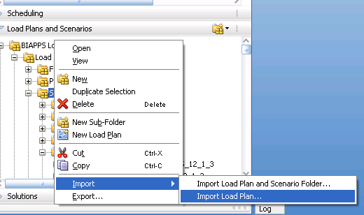

Select Import Type as > **Synonym Mode INSERT_UPDATE** > File import directory (location) > Select on the below mentioned files from the screen shot

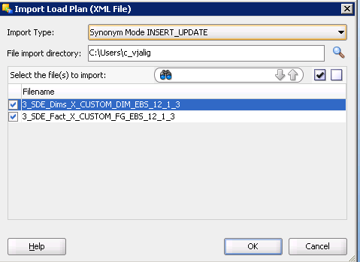

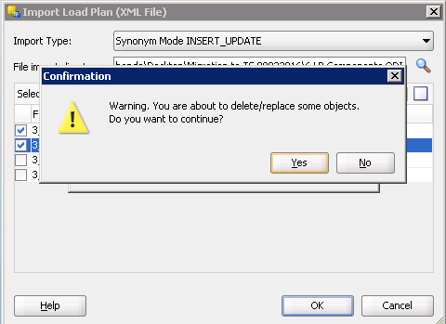

Click OK.

**NOTE:** Follow the below screen shots while importing the above two(Script#3,4) SIL XML files.

Go to the Designer navigator, Select Load Plans and Scenarios then BIAPPS Load Plan > **Load Plan Dev Components** > SIL > Right Click > Import > Import Load Plan

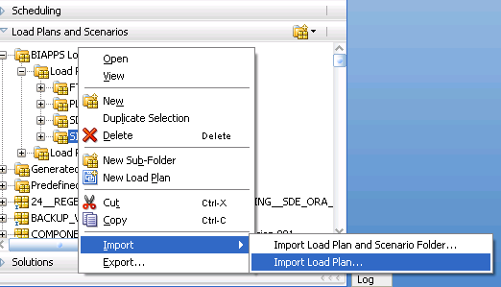

Select Import Type as > Synonym Mode INSERT_UPDATE > File import directory (location) > Select on the below mentioned files from the screen shot

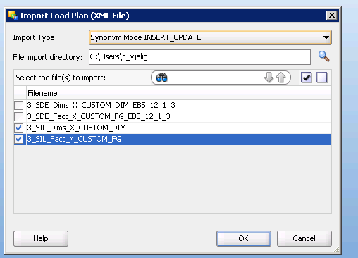

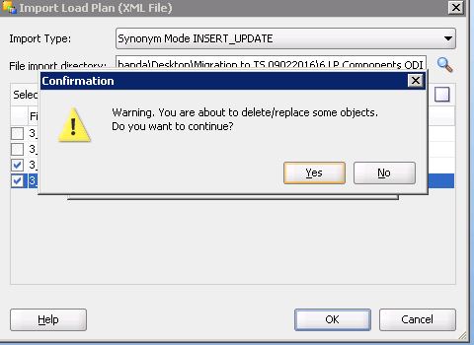

Click OK

### Verify the above Imported LP steps

Verification of SDE Step:

Go to the Designer navigator, Select Load Plans and Scenarios then BIAPPS Load Plan > **Load Plan Dev Components** > SDE > Expand EBS_12_1_3

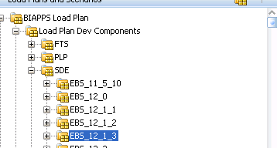



Double click on 3 SDE Dims X_CUSTOM_DIM EBS_12_1_3

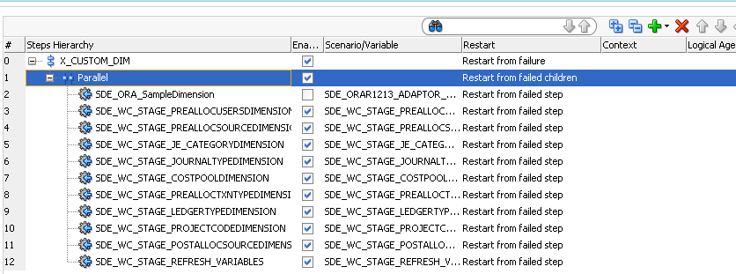

Make sure the above highlighted exists.

Similarly Double click on “3 SDE Fact X_CUSTOM_FG EBS_12_1_3”



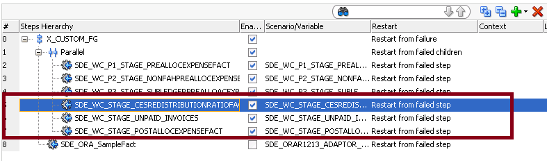

Make sure the above highlighted components are exist.

Verify SIL Load Plan components:

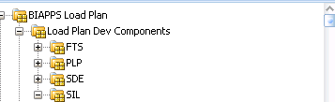

Expand the SIL

Double click : “3 SIL Dims X_CUSTOM_DIM”



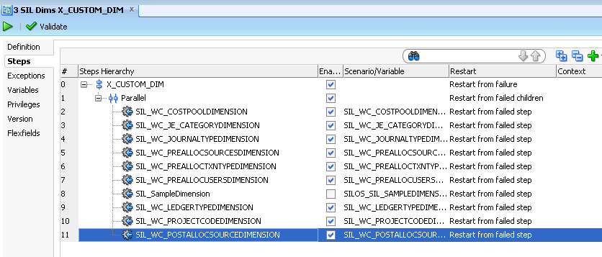

Make sure the above highlighted exists.

Similarly

Verify : 3 SIL Fact X_CUSTOM_FG (Double clik to Open)



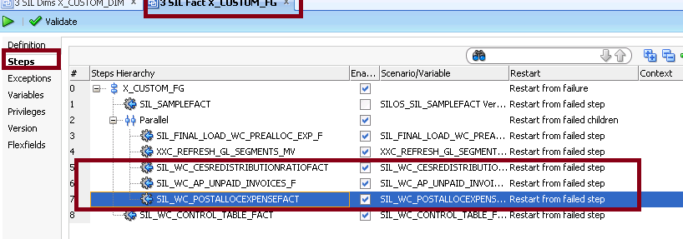

Make sure the above highlighted exists.

# Migration Steps for Units Change

### Transfer Database scripts to Target SVN repository

**NOTE:** Ensure the SVN update is complete before downloading the files from the SVN

* Copy below table creation scripts from Source SVN repository to target repository

SVN Base Path: http://subversion.sys.cigna.com/svn/ORACLE_BI_REPO

Source Location: <Source>_MAIN\DBScripts\Tables\ Release 2

Target Location : <Target>_MAIN\ DBScripts \Tables\ Release 2

#### Execute scripts in the database-DW Schema(DBA)

|  |  |  |  |  |  |  |
| --- | --- | --- | --- | --- | --- | --- |
| Script # | Dev Version # | TS Version# | CRP1 Version# | UAT Version# | PROD Version# | File Name |
| 1. | 1272 | 1280 | 1362 | 1392 |  | ALTER_FA_BALANCE_UNITS.sql |

### Transfer ODI packages to Target SVN Repository

* Copy below list ODI objects from Source SVN repository to target repository

SVN Base Path: <http://subversion.sys.cigna.com/svn/ORACLE_BI_REPO>

Source Location: <Source>_MAIN\ODI\OOB_Custom\ Release 2

Target Location : <Target>_MAIN\ODI\OOB_Custom\ Release 2

### Import ODI code components into Target instance

Please refer to the Section 3.1.3 on how to import the scenarios.

* Complete smart importing every file listed below by following the above **Section 3.1.3** steps sequence. Save the log and send to dev team if errors are encountered.

|  |  |  |  |  |  |  |
| --- | --- | --- | --- | --- | --- | --- |
| **Script #** | **Dev Version #** | **TS Version#** | **CRP1 Version#** | **UAT Version#** | **PROD Version#** | **File Name** |
| 1. | 1271 | 1281 | 1370 | 1392 |  | SDE_ORA_FixedAssetBalanceFact.zip |
| 2. | 1271 | 1281 | 1370 | 1392 |  | SIL_FixedAssetBalanceFact.zip |
| 3. | 1271 | 1281 | 1370 | 1392 |  | PLP_FixedAssetBalanceFact_Extrapolation.zip |
| 4. | 1271 | 1281 | 1370 | 1392 |  | PLP_FixedAssetBalanceFact_GapHandling.zip |

**NOTE:** You can ignore/overwrite the OOB table(W_%) errors shown while importing any of the above packages

### Re-generate the Custom ODI Packages

* Regenerate the below Custom package scenarios

Desginer : Goto Projects > BI Apps Project > Mappings > Folder Name>Packages>Scenarios >Right click Re-generate

| Script # | File Name(Scenario) | Folder Name |
| --- | --- | --- |
| 1. | SDE_ORA_FIXEDASSETBALANCEFACT | ODI Designer->Projects->Mappings-> CUSTOM_SDE_ORAR1213_Adaptor -> SDE_ORA_FixedAssetBalanceFact |
| 2. | SIL_FIXEDASSETBALANCEFACT | ODI Designer->Projects->Mappings-> CUSTOM_SILOS_ORAR1213_Adaptor -> SIL_FixedAssetBalanceFact |
| 3. | PLP_FIXEDASSETBALANCEFACT_EXTRAPOLATION | ODI Designer->Projects->Mappings-> CUSTOM_PLP -> PLP_FixedAssetBalanceFact_Extrapolation |
| 4. | PLP_FIXEDASSETBALANCEFACT_GAPHANDLING | ODI Designer->Projects->Mappings-> CUSTOM_PLP -> PLP_FixedAssetBalanceFact_GapHandling |

### Note: When re-generating the senario’s , please select all/specific parameters and click on OK to complete the scenario re-generation process.

### Verification Checklist

1. Include a subset of test steps that will confirm that the customization has been installed properly.

Verify that the deployment has been completed successfully by following these steps:

**New Components – Sanity Check**

In the ODI Model, verify the below tables:

|  |  |  |  |  |
| --- | --- | --- | --- | --- |
| **Slno** | **Component_Type** | **Component_name** | **Change Desc** | **Location** |
| 1 | Table | W_FA_BALANCE_FS | New column X_UNITS should present | Model>OracleBI Applications>Fact Stage |
| 2 | Table | W_FA_BALANCE_F | New column X_UNITS should present | Model>OracleBI Applications>Fact |
| 3 | Table | W_FA_BALANCE_F_TMP | New column X_UNITS should present | Model>OracleBI Applications>Temporary |

# Migration Steps for P1 Performance fix

### Transfer Database scripts to Target SVN repository - EBS

**NOTE:** Ensure the SVN update is complete before downloading the files from the SVN

* Copy below table creation scripts from Source SVN repository to target repository

SVN Base Path: http://subversion.sys.cigna.com/svn/BFF

Source Location: <Source>\BFF_SVN\Branches\BI\admin\sql\views

Target Location: <Target>\BFF_SVN\Branches\BI\admin\sql\views

|  |  |  |  |  |  |  |  |
| --- | --- | --- | --- | --- | --- | --- | --- |
| SL No | STAT CSR | Archive Set# | Dependency | Instances | Description | File Name |  |
| 1. | 900 | 2,4 |  | DEV/TS/UAT | Drops XXC schema objects and Creates Apps schema objects | DROP_CUSTOM_PATH1_XXC_VIEWS.sql XXC_PREA_LIAB_BAL_AMT_MV_old.sql, XXC_XLA_AE_WEBADI_LIN_V_old.sql,  XXC_XLA_AE_WEBADI_HDR_V_old.sql,  XXC_XLA_WEBADI_DISTN_LINK_V_old.sql,  XXC_PREALLOC_SOURCES_V_old.sql |  |
| 2. | 899 | 2,3 | 1 | DEV/TS/UAT/PROD | Drops APPS schema objects and Creates XXC schema objects | DROP_CUSTOM_PATH1_APPS_VIEWS.sql XXC_PREA_LIAB_BAL_AMT_MV.sql, XXC_XLA_AE_WEBADI_LIN_V.sql,  XXC_XLA_AE_WEBADI_HDR_V.sql,  XXC_XLA_WEBADI_DISTN_LINK_V.sql,  XXC_PREALLOC_SOURCES_V.sql |  |

### Transfer Database scripts to Target SVN repository - DW

**NOTE:** Ensure the SVN update is complete before downloading the files from the SVN

* Copy below table creation scripts from Source SVN repository to target repository

SVN Base Path: http://subversion.sys.cigna.com/svn/BFF

Source Location: <Source>_MAIN\DBScripts\Tables Release 2

Target Location : <Target>_MAIN\\DBScripts\Tables Release 2

|  |  |  |  |  |  |  |
| --- | --- | --- | --- | --- | --- | --- |
| **Script #** | **Dev STAT Version #** | **TS Version#** | **CRP1 Version#** | **UAT Version#** | **PROD Version#** | **File Name** |
| 1. | 1332 | 1333 | 1363 | 1392 |  | W_ETL_LOAD_DATES_PREALLOC.sql |

### Transfer ODI packages to Target SVN Repository

* Copy below ODI objects from Source SVN repository to target repository

SVN Base Path: <http://subversion.sys.cigna.com/svn/ORACLE_BI_REPO>

Source Location: <Source>_MAIN\ODI\Custom\ Release 2

Target Location : <Target>_MAIN\ODI\Custom\ Release 2

|  |  |  |  |  |  |  |
| --- | --- | --- | --- | --- | --- | --- |
| Script # | Dev Version # | TS Version# | CRP1 Version# | UAT Version# | PROD Version# | File Name |
| 1. | 1328 | 1329 | 1371 | 1392 |  | SDE_WC_P1_Stage_PreallocExpenseFact.zip |
| 2. | 1328 | 1329 | 1371 | 1392 |  | SIL_WC_P1_PreallocExpenseFact.zip |

* Do SVN Commit

**NOTE:** After successful migration of the DB and ODI components, perform FULL Load on Custom Path1 after updating the ETL history table by the below script.

**UPDATE <*DW Schema*>.W_ETL_LOAD_DATES SET COMMITTED='0'**

**WHERE TARGET_TABLE_NAME IN**

**('WC_PREALLOC_EXP_F','WC_WEBADI_PREALLOC_FS','WC_NONFAH_PREALL_EXP_FS','WC_SL_PREALLOC_FS');**

**COMMIT;**

# Migration Steps for Creating New Load Plan for the Post-Alloc

Create a new Load plan for the Post Allocation – Click on the green + to create a new load plan

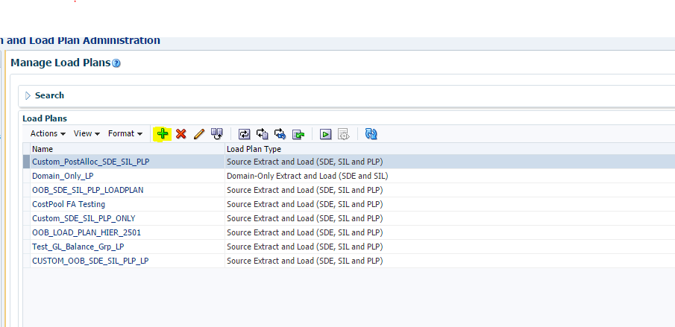

Select the new load plan and type – Click Next

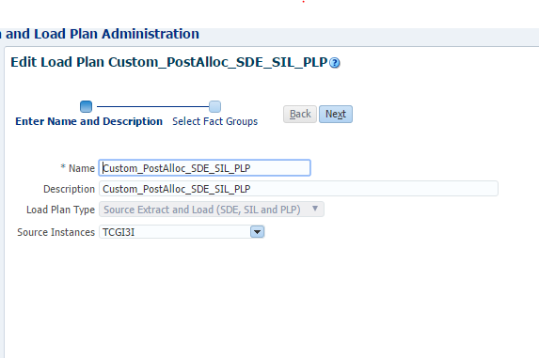

Select the Oracle custom Analytics

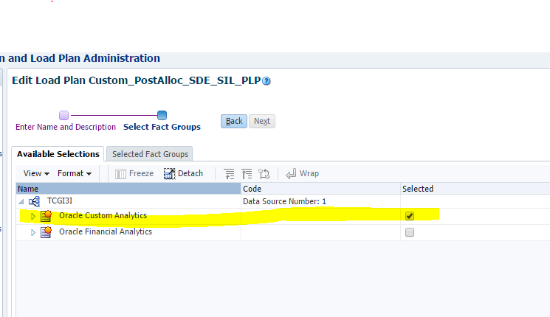

Save and Generate the load plan .

Now login into the ODI Studio and open Operator – Find the load plan created

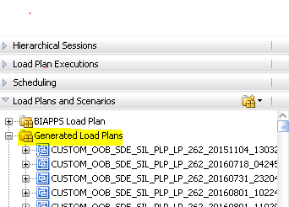

Open the new load plan created.

Expand SDE FACT group and Disable the items show below except POSTALLOC Related items.

SDE Fact Group :

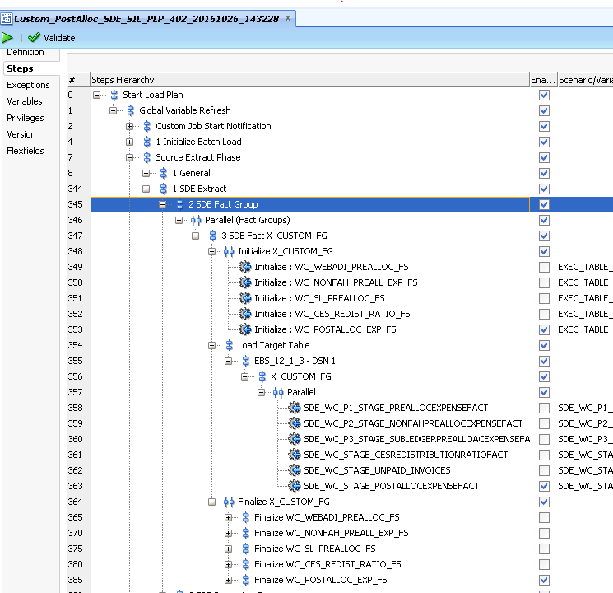

SDE Dimension Group :

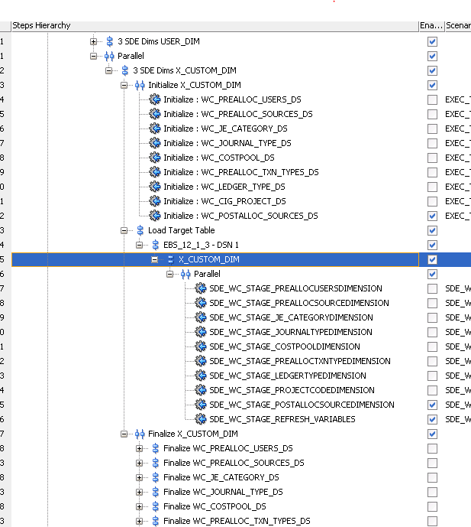

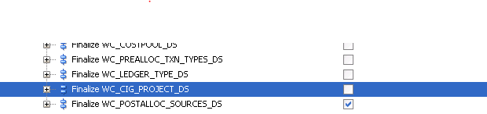

Disable SIL Facts and Dimensions expect Post Allocation related items

SIL Dimension:

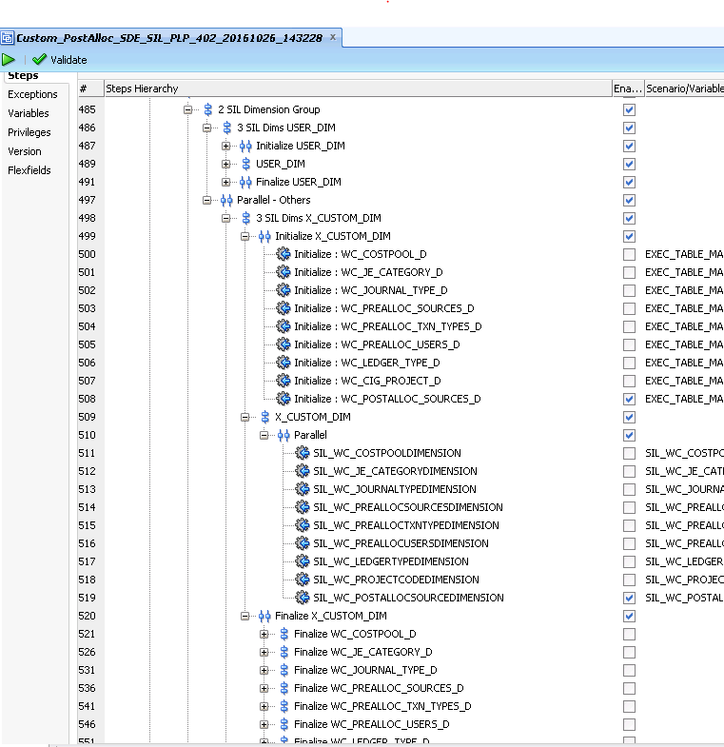

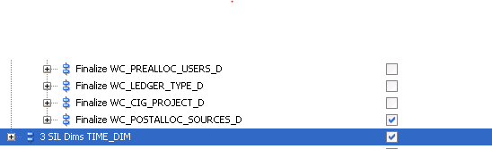

SIL Fact:

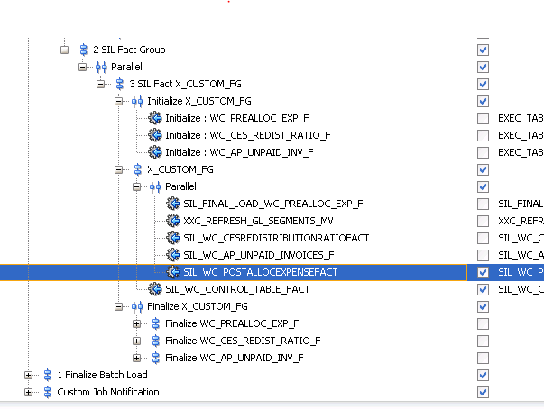

Note : Do not Regenerate the New Load Plan created for the Post Alloc after including the changes . It will refresh and enable the items which are disabled

# Re-Generate Load Plan in the Target instance

* Login to BI Configuration Manager as bi apps administrator. Pick work repository option
* Navigate to Manage Load Plans

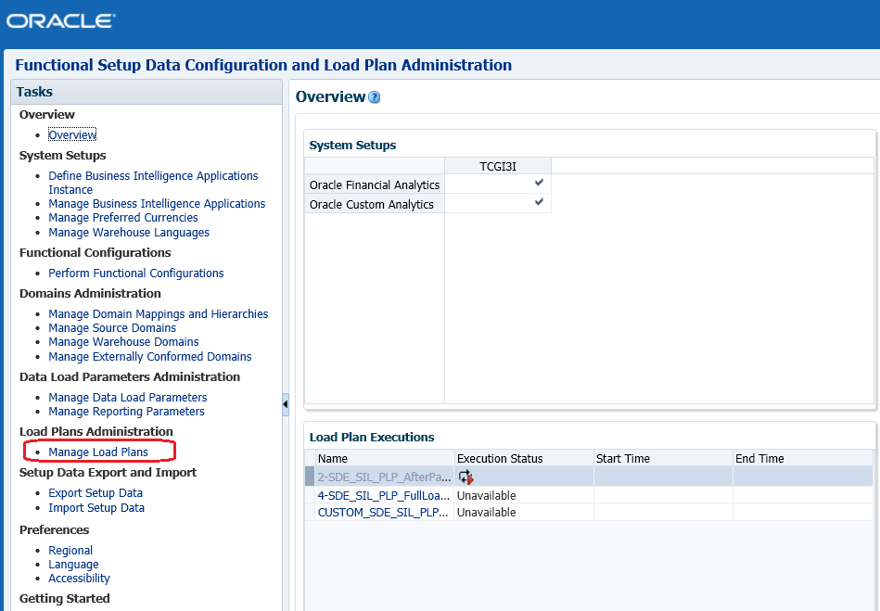

* Select the (Custom + OOB) Load Plan and then hit the Generate Icon.
* Once the generation is successful the status will show as GREEN

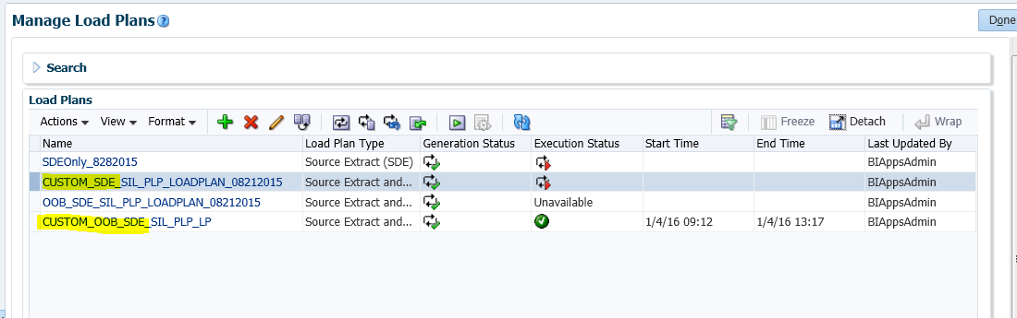

Note : Do not Regenerate the New Load Plan created for the Post Alloc after including the changes . It will refresh and enable the items which are disabled

## Execute Load Plan in the Target instance

**IMPORTANT**: Bounce all BI and managed servers and data warehouse database before kicking off the load (OPTIONAL - if already done).

* Flush target database SGA
* Disable the scheduler before executing the load .
* Once the Load plan generated without any warnings/errors, load plan is ready for execution.
* select the Custom Only Load plan and then hit the ‘Execute’ button for Custom FULL LOAD (**no need to ‘Reset the Data warehouse scenario’)**

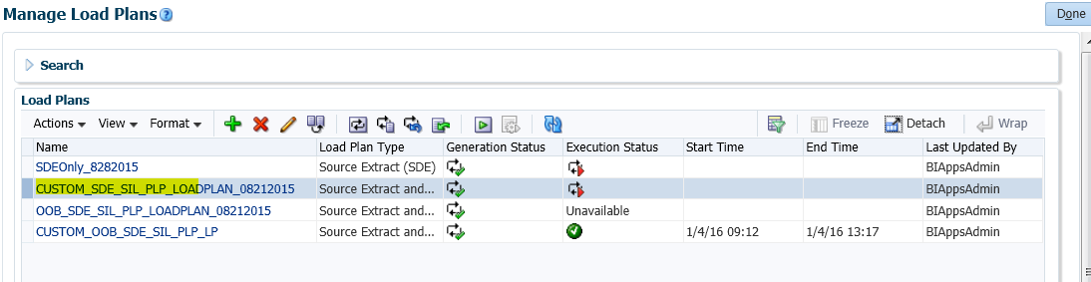

* Once the Load is completed, the status should turn to Green without any warnings.
* Then select the Custom+OOB Load plan and then hit the ‘Execute’ button for the INCREMENTAL Custom+OOB LOAD.

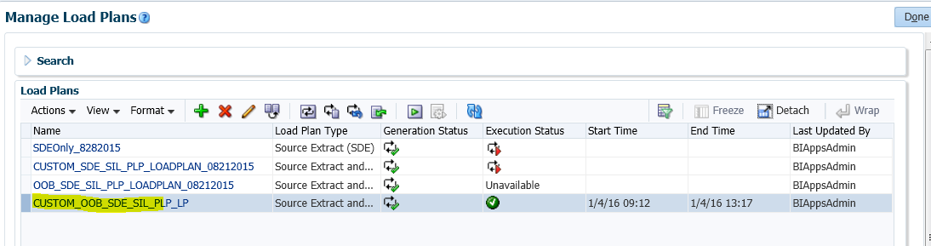

* Once the Load is completed, the status should turn to Green without any warnings.

# Execute the Historical Scripts after the Incremental load(DBA)

* Once the Incremental (OOTB+Custom) load is completed successfully, run the historical scripts in the Data wareshoue (DW).
* Refer to the following link for the script details information.

Note: Do not run Full custom load as OOB Fact wids are dependent on the custom dimensions . Check the dependency of the wids before running a custom full load.

<https://centralhub.cigna.com/project/epms13058/Expense%20Reporting/Release%202/TCS-Development/08-CV-055%20Migration%20Documents%20MD/IM-090_BI-ETL-REL2_HISTORICAL_DATA_FIX_MIGRATION_DOC.docx>

|  |  |  |
| --- | --- | --- |
| Script # | UAT Version# | File Name |
| 1 | 1393 | X_SUMMARY_FLAG_BLNCING_SEGMENT_HIST_UPD_DFIX.sql |
| 2 | 1393 | X_SUMMARY_FLAG_COST_CNTR_HIST_UPD_DFIX.sql |
| 3 | 1393 | X_SUMMARY_FLAG_NATURAL_ACCNT_HIST_UPD_DFIX.sql |
| 4 | 1393 | X_PO_VENDOR_DTLS_HIST_UPD_DFIX.sql |

# Open and Closed Issues

1. Add open issues that you identify while writing or reviewing this document to the open issues section. As you resolve issues, move them to the closed issues section and keep the issue ID the same. Include an explanation of the resolution.  
     
   When this work product is complete, any open issues should be transferred to the project- or process-level Issue Log (Manage focus area) and managed using a project level Issue Form (Manage focus area). In addition, the open items should remain in the open issues section of this work product, but flagged in the resolution column as being transferred.

## Open Issues

| ID | Issue | Resolution | Responsibility | Target Date | Impact Date |
| --- | --- | --- | --- | --- | --- |
|  |  |  |  |  |  |
|  |  |  |  |  |  |
|  |  |  |  |  |  |
|  |  |  |  |  |  |

## Closed Issues

| ID | Issue | Resolution | Responsibility | Target Date | Impact Date |
| --- | --- | --- | --- | --- | --- |
|  |  |  |  |  |  |
|  |  |  |  |  |  |
|  |  |  |  |  |  |
|  |  |  |  |  |  |